EXPERIMENT:05

NAME: MAUNEESHWARAN.N ROLL NO:240701307

Experiment Title: The Frictionless Purchase Funnel
Hypothesis: By providing a consolidated checkout "pop" (modal) rather than a multi-page checkout process, the user will experience lower cognitive load and a higher completion rate.
1. The Variables
- Independent Variable: The navigation flow and UI layout (the wireframe design).
- Dependent Variable: The "Conversion Rate" (percentage of users who reach the Order Confirmation screen) and "Time-to-Purchase."
- Control Factors: Consistent bottom navigation and top header "Delicious" branding to maintain user orientation.
2. Experimental Phases (The User Journey)
Phase A: Identity Verification (Registration/Login)
The experiment begins by establishing a user profile. The layout tests whether a minimalist "User Name/Password" field set reduces the "bounce rate" during the high-friction entry point.
Phase B: Information Architecture (Home & Product Description)
The user enters the "Discovery Phase."
- Home Page: Uses a grid system to test visual scanning patterns.
- Product Description: Tests the effectiveness of "Social Proof" indicators (Heart/Favorite icons and Share icons) in influencing the user's decision to add an item to the cart.
Phase C: The Micro-Conversion (My Cart)
The user interacts with a Quantity Adjuster. This is a functional test to see if users find the increment/decrement symbols intuitive for managing their budget before the final commitment.
Phase D: The Critical Transition (The "Pop")
The screen labeled "pop" is the core of the experiment. Instead of a new page, it uses an overlay (modal) for delivery and payment details.
- Purpose: To test if keeping the background context (the cart) visible reduces "User Anxiety" during payment.
Phase E: Post-Action Feedback (Order Confirmation)
The experiment concludes with a Success Message and a 5-star rating scale. This measures the "Peak-End Rule"—the psychological theory that people judge an experience largely based on how they felt at its peak and its end.
3. Data Collection Points
During this experiment, a researcher would track:
- Drop-off Points: Where do users exit? (e.g., if they leave at the Login screen, the friction is too high).
- Interaction Frequency: How many times do they click "Similar Items" before adding to the cart?
- Rating Score: The final star rating provides the qualitative data to match the quantitative flow data.
4. Conclusion & Expected Outcome
If the experiment is successful, the data should show a "linear progression" with minimal backtracking. The presence of the "Go Back To Home" button on the final screen suggests a Retention Loop, inviting the subject to restart the experiment (shopping cycle) immediately.
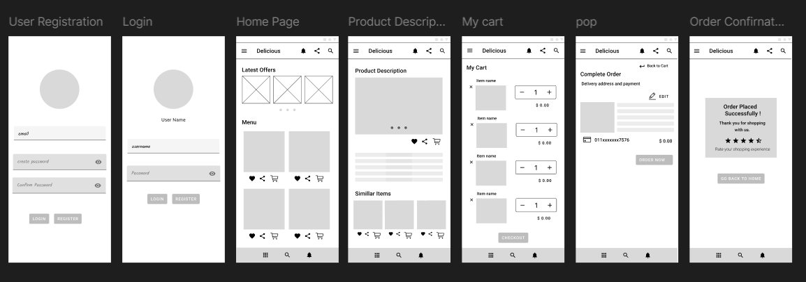

https://lucid.app/lucidchart/078a42a9-0a9b-4b5f-9ed4-a071d145e03a/edit?viewport_loc=-2279%2C-471%2C3580%2C2241%2C0_0&invitationId=inv_86a3f164-ea1d-40aa-9319-d8cd00b79198

